**Liberty University**

**CSIS 331**

**Lab 6 Answer Sheet**

**Submit this completed document with your completed and saved packet tracer in the link provided in Blackboard.**

Complete the table

|  |  |  |  |
| --- | --- | --- | --- |
| **Device** | **IPv4 Address** | **IPv4 Subnet Mask** | **IPv6 Address/Prefix** |
| Branch-A G0/0 | 172.20.16.1 | 255.255.254.0 | N/A |
| Branch-A G0/1 | 172.20.18.1 | 255.255.255.0 | N/A |
| Branch-B G0/0 | N/A | | 2001:DB8:FADE:00FF::1/64 |
| Branch-B G0/1 | N/A | | 2001:DB8:FADE:0100::1/64 |
| **Device** | **IPv4 Address** | **IPv4 Subnet Mask** | **IPv4 Default Gateway** |
| PC-A1 NIC | 172.20.17.254 | 255.255.254.0 | 172.20.16.1 |
| PC-A2 NIC | 172.20.18.254 | 255.255.255.0 | 172.20.18.1 |
| **Device** | **IPv6 Address /Prefix** | | **IPV6 Default Gateway** |
| PC-B1 NIC | 2001:DB8:FADE:00FF::10/64 | | FEb0::B |
| PC-B2 NIC | 2001:DB8:FADE:0100::10/64 | | FEb0::B |

Copy and Paste Branch A show run Output:

Branch-A#show run

Building configuration...

Current configuration : 969 bytes

!

version 15.1

no service timestamps log datetime msec

no service timestamps debug datetime msec

service password-encryption

!

hostname Branch-A

!

!

!

enable secret 5 $1$mERr$9cTjUIEqNGurQiFU.ZeCi1

!

!

!

!

!

!

ip cef

no ipv6 cef

!

!

!

!

license udi pid CISCO2911/K9 sn FTX1524A906

!

!

!

!

!

!

!

!

!

!

!

spanning-tree mode pvst

!

!

!

!

!

!

interface GigabitEthernet0/0

ip address 172.20.16.1 255.255.254.0

duplex auto

speed auto

!

interface GigabitEthernet0/1

ip address 172.20.18.1 255.255.255.0

duplex auto

speed auto

!

interface GigabitEthernet0/2

ip address 172.20.31.254 255.255.255.252

duplex auto

speed auto

!

interface Vlan1

no ip address

shutdown

!

router rip

version 2

network 172.20.0.0

no auto-summary

!

ip classless

!

ip flow-export version 9

!

!

!

banner motd ^C warning ^C

!

!

!

!

!

line con 0

password 7 0822455D0A16

login

!

line aux 0

!

line vty 0 4

password 7 0822455D0A16

login

line vty 5 15

password 7 0822455D0A16

login

!

!

!

end

Copy and Paste Branch B show run Output:

Branch-B#show run

Building configuration...

Current configuration : 1287 bytes

!

version 15.1

no service timestamps log datetime msec

no service timestamps debug datetime msec

service password-encryption

!

hostname Branch-B

!

!

!

enable secret 5 $1$mERr$9cTjUIEqNGurQiFU.ZeCi1

!

!

!

!

!

!

ip cef

ipv6 unicast-routing

!

no ipv6 cef

!

!

!

!

license udi pid CISCO2911/K9 sn FTX1524J0Q5

!

!

!

!

!

!

!

!

!

!

!

spanning-tree mode pvst

!

!

!

!

!

!

interface GigabitEthernet0/0

no ip address

duplex auto

speed auto

ipv6 address FE80::B link-local

ipv6 address 2001:DB8:FADE:FF::1/64

ipv6 address 2001:DB8:FADE:FF::10/64

ipv6 rip branch-b enable

!

interface GigabitEthernet0/1

no ip address

duplex auto

speed auto

ipv6 address FE80::B link-local

ipv6 address 2001:DB8:FADE:100::1/64

ipv6 address 2001:DB8:FADE:100::10/64

ipv6 rip branch-b enable

!

interface GigabitEthernet0/2

no ip address

duplex auto

speed auto

ipv6 address FE80::B link-local

ipv6 address 2001:DB8:FFFF:FFFF::2/64

ipv6 rip branch-b enable

!

interface Vlan1

no ip address

shutdown

!

ipv6 router rip branch-b

!

ip classless

!

ip flow-export version 9

!

!

!

no cdp run

!

banner motd ^C warning ^C

!

!

!

!

!

line con 0

exec-timeout 0 0

password 7 0822455D0A16

login

!

line aux 0

!

line vty 0 4

password 7 0822455D0A16

login

line vty 5 15

password 7 0822455D0A16

login

!

!

!

end

Ping Output:

|  |  |  |  |
| --- | --- | --- | --- |
| **Ping From Device IP** | **Ping to Device IP** | **Results** | **How did you resolve any errors?** |
| PC-A1 | PC-A2 | Data sent |  |
| PC-B1 | PC-B2 | Data sent |  |

Screenshot of IPv4 PCs can access the web page at central.pka:

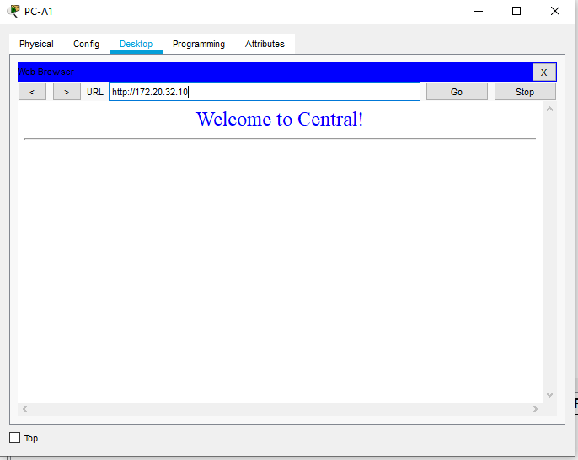

Screenshot of IPv6 PCs can access the web page at centralv6.pka:

